Assignment 12

R-6.1 Draw a simple undirected graph G that has 12 vertices, 18 edges, and 3 connected components. Why would it be impossible to draw G with 3 connected components if G had 66 edges?

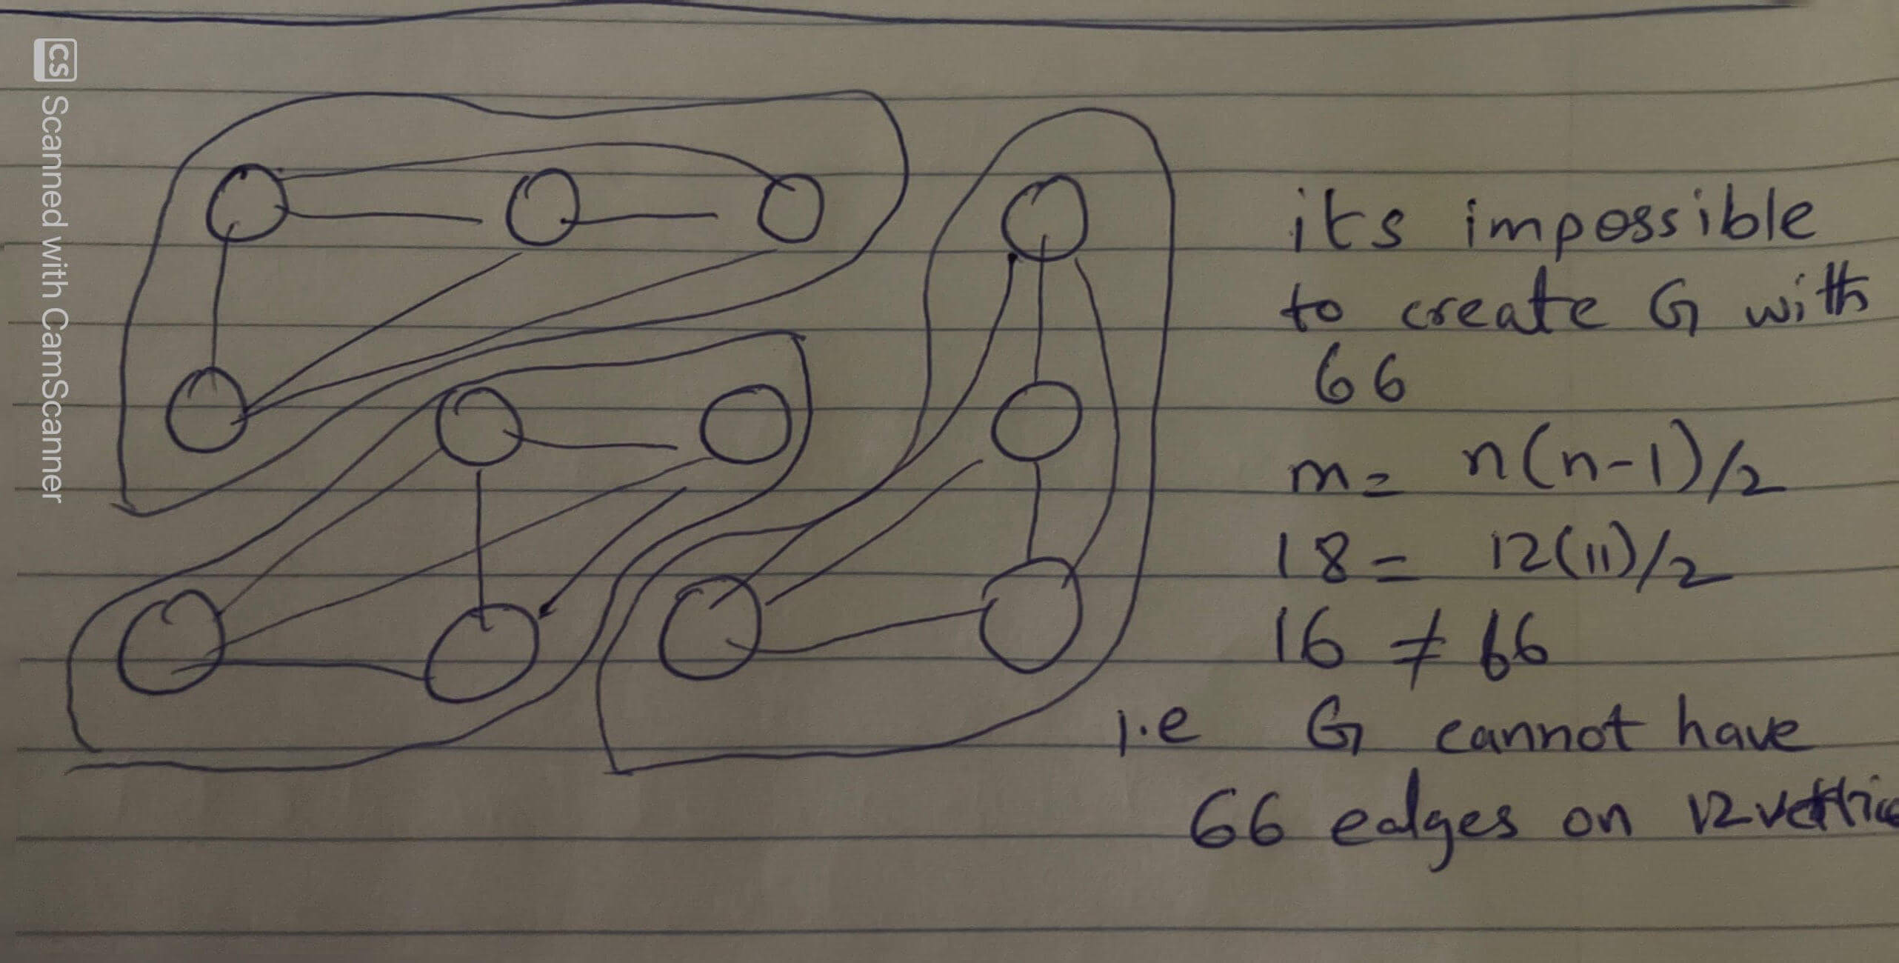

R-6.4 Bob loves foreign languages and wants to plan his course schedule to take the following nine language courses: LA15, LA16, LA22, LA31, LA32, LA126, LA127, LA141, and LA169. The course prerequisites are:

* •  LA15: (none)
* •  LA16: LA15
* •  LA22: (none)
* •  LA31: LA15
* •  LA32: LA16, LA31
* •  LA126: LA22, LA32
* •  LA127: LA16
* •  LA141: LA22, LA16
* •  LA169: LA32

Find a sequence of courses that allows Bob to satisfy all the prerequisites.

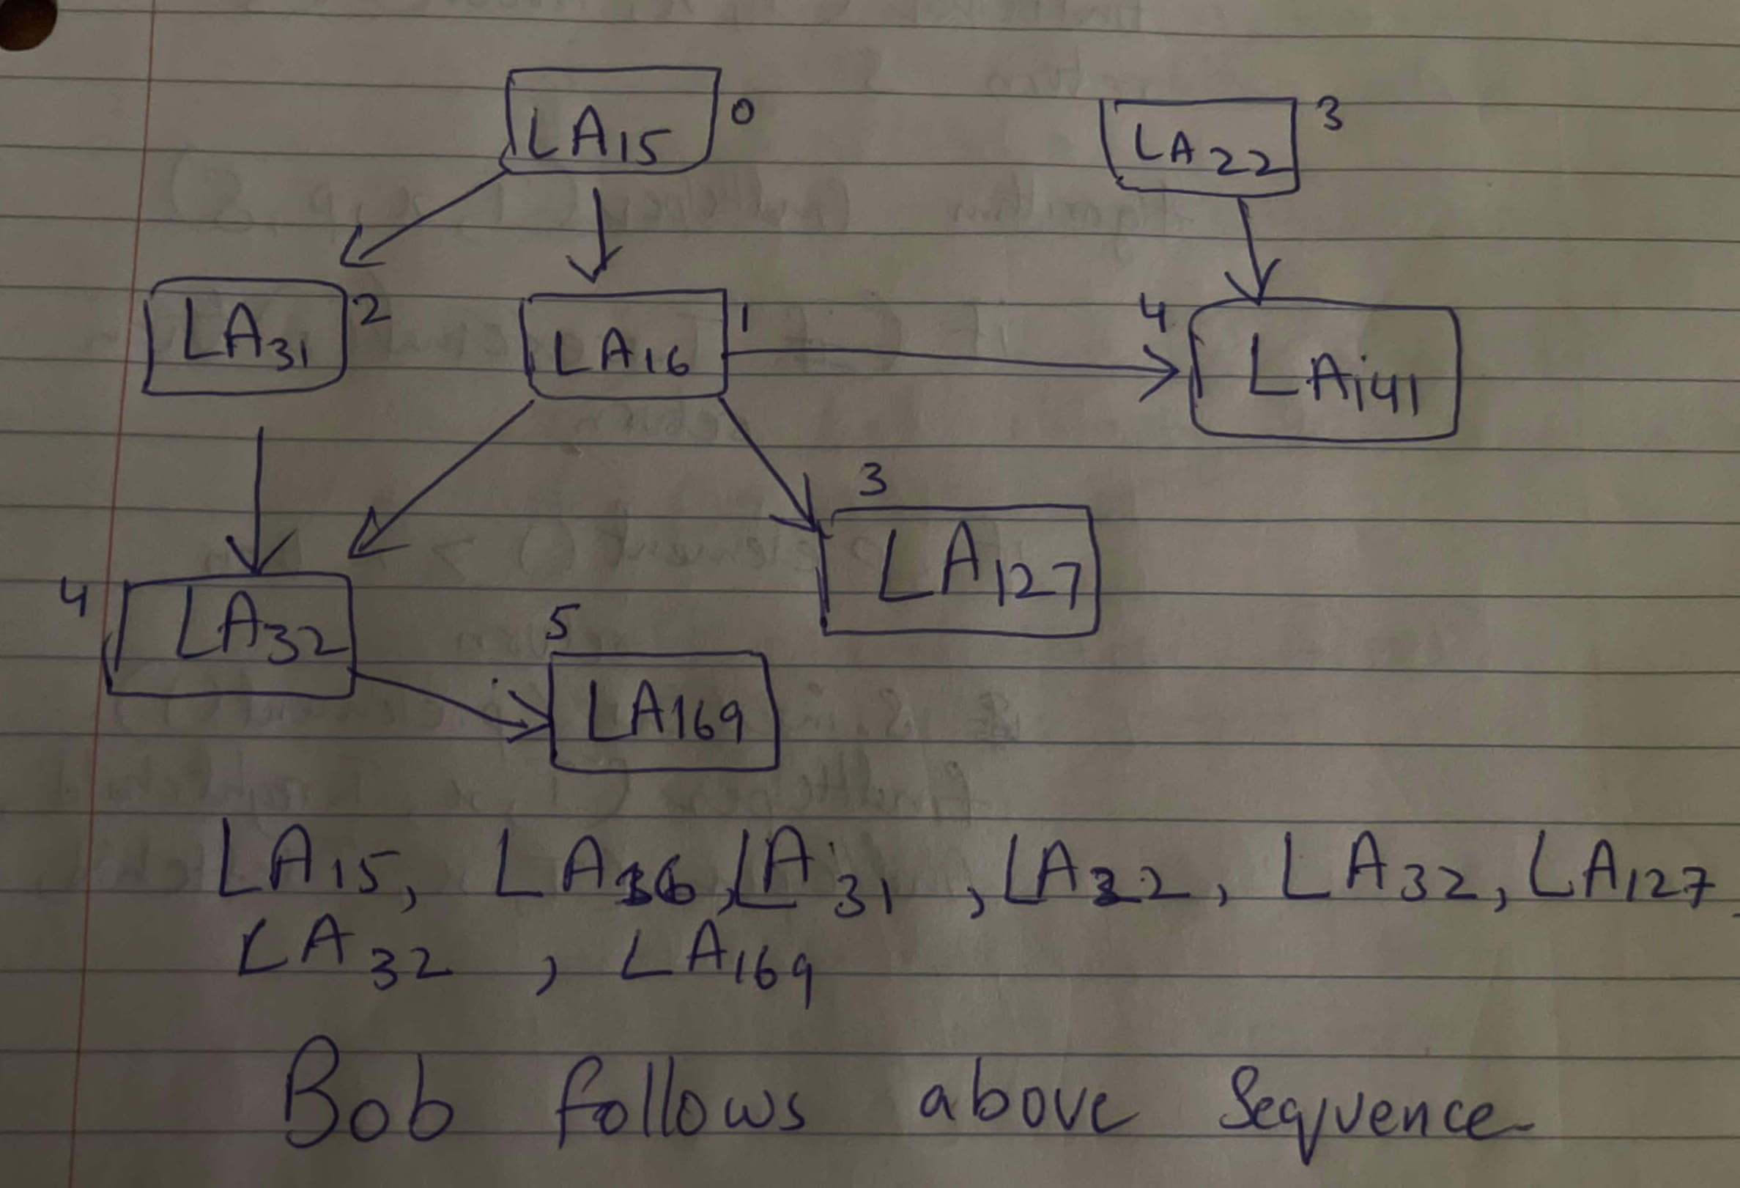

R-6.7 Would you use the adjacency list structure or the adjacency matrix structure in each of the following cases? Justify your choice.

1. The graph has 10,000 vertices and 20,000 edges, and it is important to use as little space as possible.

**Adjacency list structure: It uses less space because it only stores the necessary connections between vertices, which is advantageous for a graph with 10,000 vertices and 20,000 edges.**

1. The graph has 10,000 vertices and 20,000,000 edges, and it is important to use as little space as possible.

**Adjacency matrix structure: It is suitable for dense graphs as it provides efficient access and traversal of neighbors, which is important for a graph with 10,000 vertices and 20,000,000 edges.**

1. You need to answer the query areAdjacent as fast as possible, no matter how much space you use.

**Adjacency matrix structure: It allows for constant-time access to determine adjacency, which is important when speed is a priority, regardless of the space usage.**